**Machine Problem Proposal**

Submitted to: Sir Adomar Ilao

Members:

* TAYAG, Francis Michael
* MARASIGAN, Miguel Christian
* OLIVAREZ, Karl Ulrich
* RAPISTA, A.G. Matthew

**Background of the Project**

Web Wizards, Inc. is a startup web company engaging in the e-commerce business or online trading. It has its own e-commerce platform called DataWiz. The e-commerce platform primarily focuses on computer accessories and hardware. DataWiz is a website that serves as a platform for conducting e-commerce activities such as online trading, and buy-and-sell.

**Organizational Structure**

The development team is split into two groups, front-end and back-end. However, this structure is flexible so that the members of different group can contribute to the other group. This is to facilitate rapid development and make effective use of manpower.

|  |  |
| --- | --- |
| Back-end Development | Front-end Development |
| Tayag, Francis Michael | Olivarez, Karl Ulrich |
| Rapista, A.G. Matthew | Marasigan, Miguel Christian |

**Specific Description of the Information System**

The information system or the e-commerce platform has an index page where the latest and most popular products are showcased. From there, the user can browse the index, search for products, add to cart, and login to their account.

When browsing the index, the user can view the showcased products or search for a specific product in the search bar. The user can also add to cart their desired items but the user needs to be logged in before checking out a product.

The users of the platform can also visit the about us page where they can see the background of the developers of the system and the background of the business. Users can go to the contact us page where they can see the company’s contact information if they have any inquiries or concerns with regard to the system.

For the back-end of the system, there is the trade ledger where all the records of the transactions and trades are kept and managed. The user, with the website as an interface, can view these transactions through their “Trade History” web page. Any trades that are completed are automatically put into the trade ledger database.

The back-end also stores users’ account information such as username, password, products to trade, their trade requests, trade history, and basic information.

When requesting to trade, the user specifies what product to take and the system processes their input, pulls their request from the database if found, and adds it to the cart of the user. The converse is true if the user wants to trade the product back.

Shipping is simply checking out what the user wanted to buy. At this point, the totals are calculated, the back-end gets updated, and the transaction is completed.

**Front-end Website Map**

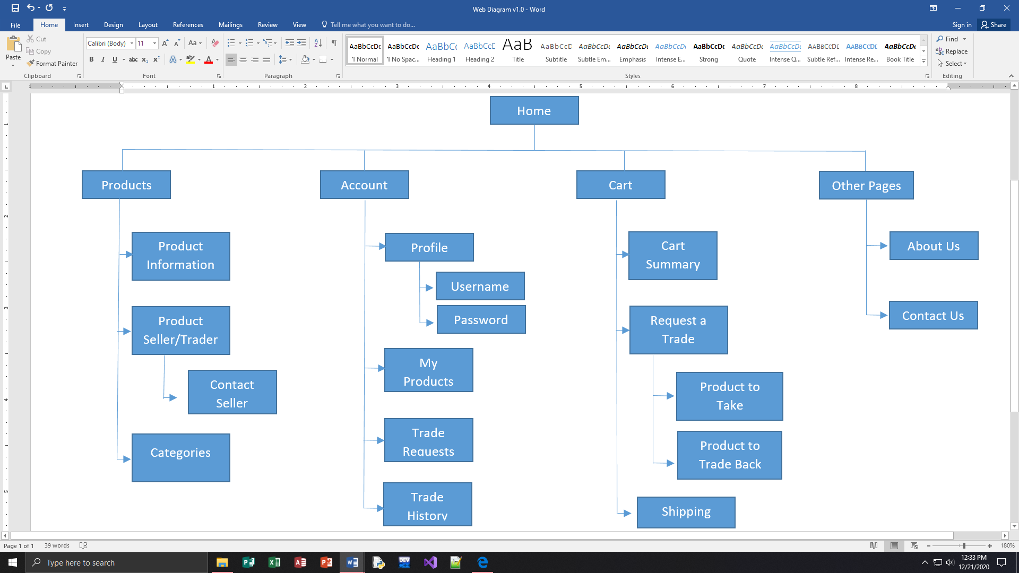

**Back-end Website Map**

db_TradeLedger

**URL Address of the developed Website**

tbl_Trader (table for user)

* Trader_ID
* Trader_Name
* Trader_Pass
* Trader_Contact

tbl_Cart (table for trade history)

* Trader_ID (Requester)
* Product_ID (From seller)
* Product_Name (From seller)
* Seller_ID (Trader_ID of seller)
* Seller_Name (Trader_Name of seller)

tbl_History (table for trade history)

* Trader_ID (Requester)
* Receiver_ID (Trader_ID of receiver)
* Product_Take (Product_ID of requested item)
* Product_Give (Product_ID of item to given back as trade)
* Shipping

tbl_Request (table for product)

* Trader_ID (Requester)
* Receiver_ID (Trader_ID of receiver)
* Product_Take (Product_ID of requested item)
* Product_Give (Product_ID of item to give back as trade)
* Shipping

tbl_Product (table for product)

* Trader_ID
* Product_ID
* Product_Name
* Product_Desc
* Product_Categ